Press release 3/2012
DYNAmore GmbH
Gesellschaft für FEM-
Ingenieurdienstleistungen
DYNAmore LS-DYNA Forum 2012 –
a huge success once again
Stuttgart, 22nd October 2012 –

Over 350 participants from 24 countries visited this year’s LS-DYNA forum, which took place in Ulm in Southern Germany from 9th – 10th October. With 96 high-quality presentations, live demonstrations and rounds of talks, the forum presented a remarkable platform for exchanging information on the topics of LS-DYNA, LS-OPT and associated CAE process chains.

The diverse range of technical presentations from different branches of industry enabled participants to gain a comprehensive overview of applications, possibilities and concepts regarding LS-DYNA and LS-OPT. This year, for example, a number of speeches were given on the simulation of composites and fiber-reinforced plastics. The lectures were divided in an application-orientated way into the usual focal points of crash, passenger and forming simulations and also material modeling. Fascinating contributions were also made about multi-physical simulation possibilities in LS-DYNA as well as about the special fields of optimization, advanced passenger simulation and CAE processes.

The congress program was rounded off by software engineers who, through lectures and live demonstrations, gave an insight into the application possibilities of new implementations. Keynote speeches were delivered by representatives of Daimler, ThyssenKrupp Steel Europe, Brose Fahrzeugteile, Jaguar/Landrover and LSTC. A scientific contribution was made by Prof. Ehlers from the Cluster of Excellence Simulation Technology (SimTech) at Stuttgart University, who gave a lecture about the challenges of simulating coupled problems.

The accompanying exhibition involving 22 hardware and software manufacturers informed about current innovations and trends in the field of LS-DYNA.

For more information, please contact:
DYNAmore GmbH
Industriestr. 2
D-70565 Stuttgart
Tel.: +49-(0)711-4596000
info@dynamore.de
www.dynamore.de

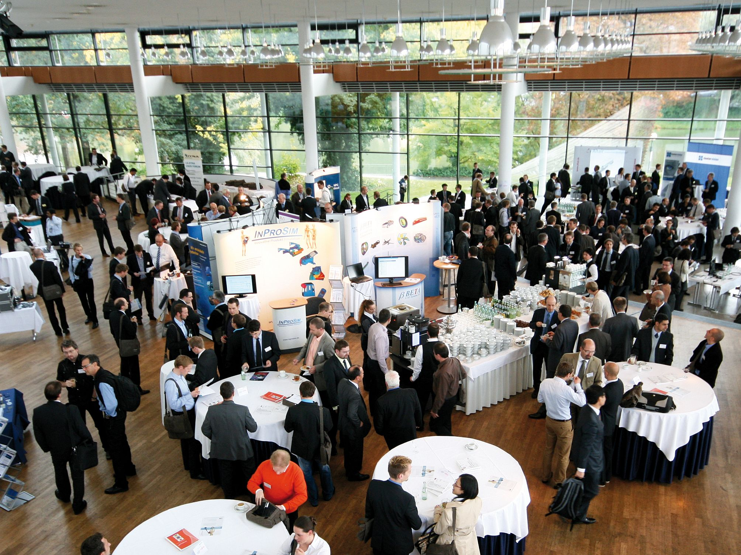

DYNAmore LS-DYNA Forum 2012 – hardware and software exhibition

