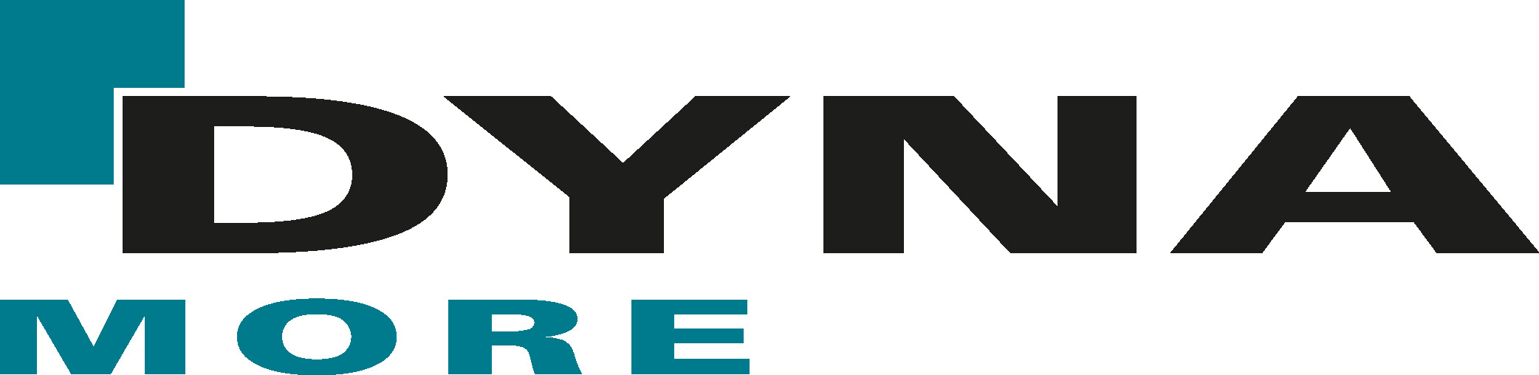

Media Contacts:
Keisa Allen
ETA Inc., Marketing Manager
kallen@eta.com
248.307.2336

FOR IMMEDIATE RELEASE
ETA Inc., Engineering Technology Associates Announces DYNAmore as Master Distributor

TROY, Michigan (USA) /STUTTGART, Germany – September 8, 2020 –
ETA Inc. (Engineering Technology Associates), an engineering and software innovator with over 37 years in the automotive engineering community, has signed a master distribution agreement with DYNAmore GmbH. DYNAmore is one of the largest distributors of LS-DYNA simulation software worldwide.

“I highly appreciate to further strengthen our long-standing and very good cooperation with ETA and to coordinate the distribution of Dynaform throughout Europe. Together we are well positioned to meet the increasing demands on deep drawing, hydroforming and tube bending simulations.”
Ulrich Franz, Managing Director, DYNAmore GmbH

‘It is my pleasure to welcome DYNAmore, our long time Dynaform partner and German distributor as our new Master Distributor for Dynaform in the European Union. I am pleased by DYNAmore’s business expansion, as they increase their presence in new growth markets across Europe.’
– Dr. Akbar Farahani, CEO & President, ETA Inc.

ETA and DYNAmore have been the most prominent LS-DYNA distributors for over 25 years. This new partnership will bring both companies closer, strengthen the software sales and support to the end-customer and showcase a unified market expansion to European OEMs’ and suppliers.

ETA and DYNAmore are committed to creating a powerful virtual presence with webinars, online support and training for customers during the current pandemic and beyond.

DYNAmore will lead the following efforts:
- Supporting customers with the 6th generation of Dynaform
- Providing assistance to European sub-distributors
- Delivering consistent, streamlined communication for software sales and support throughout Europe

About ETA, Inc.
Advanced product development engineers working as structural analysts for the world’s largest automotive manufacturers established ETA in 1983. ETA provides product design and development solutions, along with supplying research and analysis using CAE, CAD and optimization tools (Durability, Vehicle Dynamics, NVH, Crash/Safety, Die System Structure and Manufacturing Processes). The firm is proactive in the creation and implementation of new technology and software, ETA’s software products include; ACP OpDesign™*, Dynaform®, PreSys® and VPG Suite™. For further information on ETA, please visit eta.com or call 248.729.3010
*Accelerated Concept to Product (ACP) Process®

About DYNAmore
Experts of DYNAmore have been involved in the development of LS-DYNA since 1985. DYNAmore is one of the largest distributors of LS-DYNA simulation software. While also providing expert support in all areas of application for the LS-DYNA and LS-OPT software packages; offering FEM calculation benchmarks as well as general consulting on questions concerning structural dynamics. Additional areas of expertise include; pilot and development projects for simulating nonlinear dynamic problems, software development for solver technologies and simulation data management as well as consulting and support for modern, massively parallel computer systems.
For further information on DYNAmore, please visit www.dynamore.de/en.

